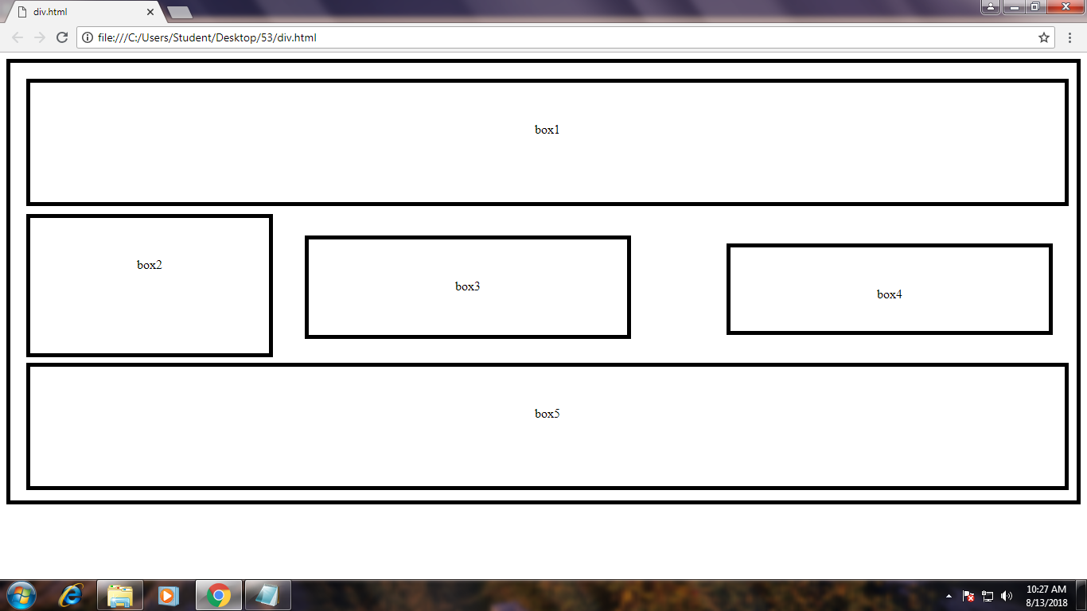

<html>

<head>

<title></title>

<style>

.box{

border:solid 5px;

width:1340px;

height:550px;

}

.box1{

border:solid 5px;

width:1200px;;

height:50px;

padding:50px;

text-align:center;

margin-left:20px;

margin-top:20px;

}

.box2{

border:solid 5px;

width:200px;

height:70px;

padding:50px;

text-align:center;

margin-top:10px;

margin-left:20px;

}

.box3{

border:solid 5px;

width:300px;

height:20px;

padding:50px;

text-align:center;

margin-top:10px;

margin-left:370px;

position:absolute;

top:220px;

}

.box4{

border:solid 5px;

width:300px;

height:5px;

padding:50px;

text-align:center;

margin-top:10px;

margin-left:900px;

position:absolute;

top:230px;

}

.box5{

border:solid 5px;

width:1200px;

height:50px;

padding:50px;

text-align:center;

position:absolute;

top:390px;

margin-left:20px;

}

</style>

</head>

<body>

<div class="box">

<div class="box1">box1</div>

<div class="box2">box2</div>

<div class="box3">box3</div>

<div class="box4">box4</div>

<div class="box5">box5</div>

</body>

</html>

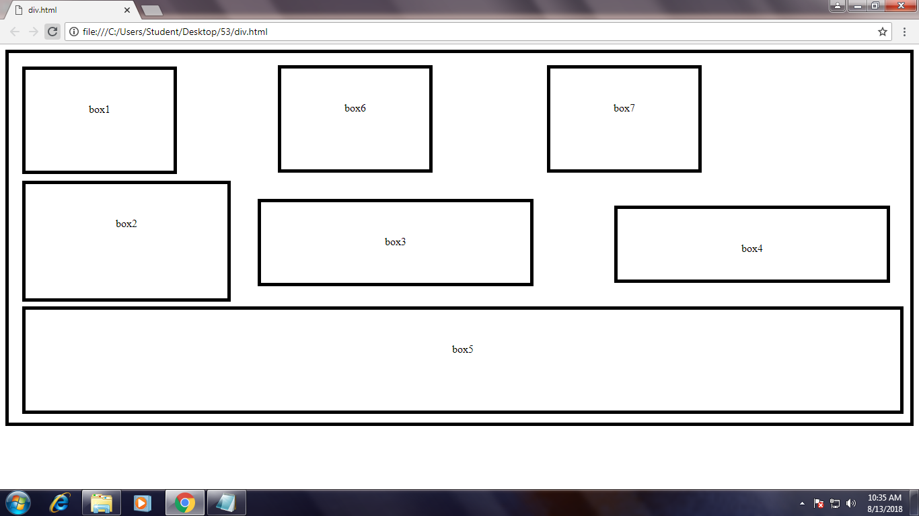

<html>

<head>

<title></title>

<style>

.box{

border:solid 5px;

width:1340px;;

height:550px;

}

.box1{

border:solid 5px;

width:120px;;

height:50px;

padding:50px;

text-align:center;

margin-left:20px;

margin-top:20px;

}

.box6{

border:solid 5px;

width:120px;;

height:50px;

padding:50px;

text-align:center;

margin-left:400px;

margin-top:20px;

position:absolute;

top:11px;

}

.box7{

border:solid 5px;

width:120px;;

height:50px;

padding:50px;

text-align:center;

margin-left:800px;

margin-top:20px;

position:absolute;

top:11px;

}

.box2{

border:solid 5px;

width:200px;

height:70px;

padding:50px;

text-align:center;

margin-top:10px;

margin-left:20px;

}

.box3{

border:solid 5px;

width:300px;

height:20px;

padding:50px;

text-align:center;

margin-top:10px;

margin-left:370px;

position:absolute;

top:220px;

}

.box4{

border:solid 5px;

width:300px;

height:5px;

padding:50px;

text-align:center;

margin-top:10px;

margin-left:900px;

position:absolute;

top:230px;

}

.box5{

border:solid 5px;

width:1200px;

height:50px;

padding:50px;

text-align:center;

position:absolute;

top:390px;

margin-left:20px;

}

</style>

</head>

<body>

<div class="box">

<div class="box1">box1</div>

<div class="box6">box6</div>

<div class="box7">box7</div>

<div class="box2">box2</div>

<div class="box3">box3</div>

<div class="box4">box4</div>

<div class="box5">box5</div>

</body>

</html>

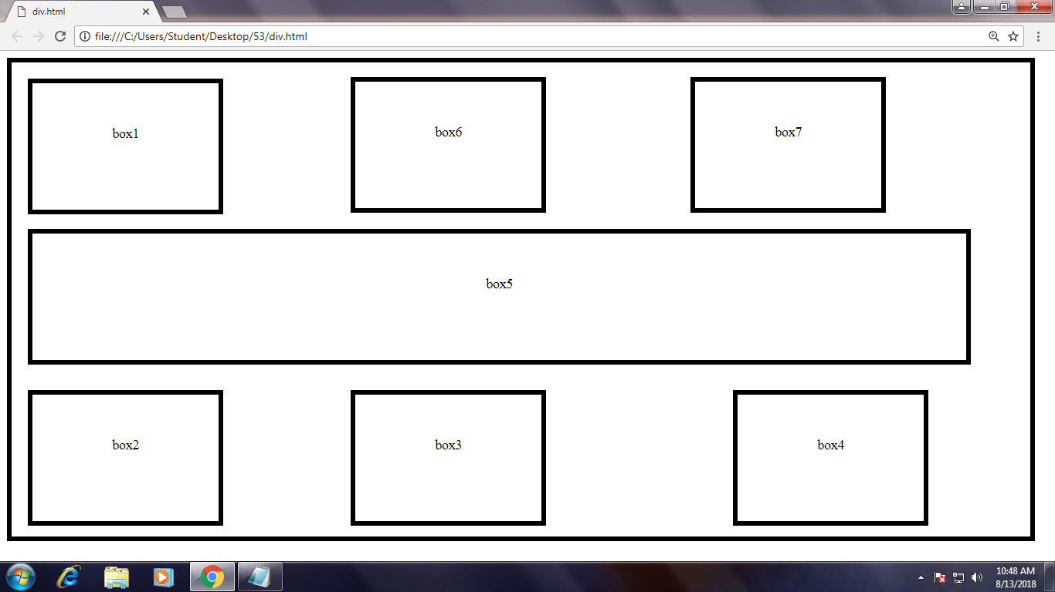

<html>

<head>

<title></title>

<style>

.box{

border:solid 5px;

width:1200px;;

height:560px;

}

.box1{

border:solid 5px;

width:120px;;

height:50px;

padding:50px;

text-align:center;

margin-left:20px;

margin-top:20px;

}

.box6{

border:solid 5px;

width:120px;;

height:50px;

padding:50px;

text-align:center;

margin-left:400px;

margin-top:20px;

position:absolute;

top:11px;

}

.box7{

border:solid 5px;

width:120px;;

height:50px;

padding:50px;

text-align:center;

margin-left:800px;

margin-top:20px;

position:absolute;

top:11px;

}

.box2{

border:solid 5px;

width:120px;

height:50px;

padding:50px;

text-align:center;

margin-top:10px;

margin-left:20px;

position:absolute;

top:390px;

}

.box3{

border:solid 5px;

width:120px;

height:50px;

padding:50px;

text-align:center;

margin-top:10px;

margin-left:400px;

position:absolute;

top:390px;

}

.box4{

border:solid 5px;

width:120px;

height:50px;

padding:50px;

text-align:center;

margin-top:10px;

margin-left:850px;

position:absolute;

top:390px;

}

.box5{

border:solid 5px;

width:1000px;

height:50px;

padding:50px;

text-align:center;

position:absolute;

top:210px;

margin-left:20px;

}

</style>

</head>

<body>

<div class="box">

<div class="box1">box1</div>

<div class="box6">box6</div>

<div class="box7">box7</div>

<div class="box2">box2</div>

<div class="box3">box3</div>

<div class="box4">box4</div>

<div class="box5">box5</div>

</body>

</html>